**Battle oft he Neighbourhoods – Part 1**

**Description of the problem and a discussion of the background. (15 marks)**

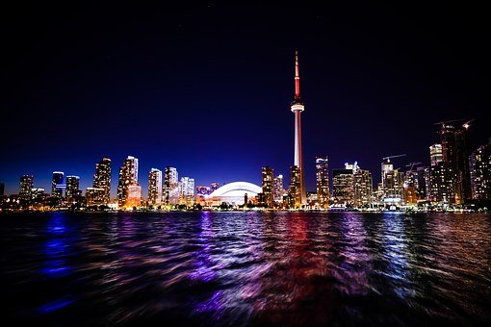

Picture taken from Pixabay.com

A young pizza baker Giorgio wants to move from his home Sicilia to Canada, preferably to Toronto, which is one of the metropolis of Canada and close to the boarder with the United States. Toronto is one of the biggest cities oft he province of Ontario. According to a study of Chefspencil (<https://www.chefspencil.com/top-10-most-popular-ethnic-cuisines-in-canada/>) Italian food is most popular in Ontario: „Ontario scored highest for Italian food among the provinces with a full 100 points. British Columbia scored second and Alberta third. While the least score went to Newfoundland and Labrador. In other words, Italian food is three times more popular in Ontario compared to Newfoundland.“ Within Ontario Toronto is in the TOP5 cities, where Italian food is likes most as following plot from Chefspencil shows:

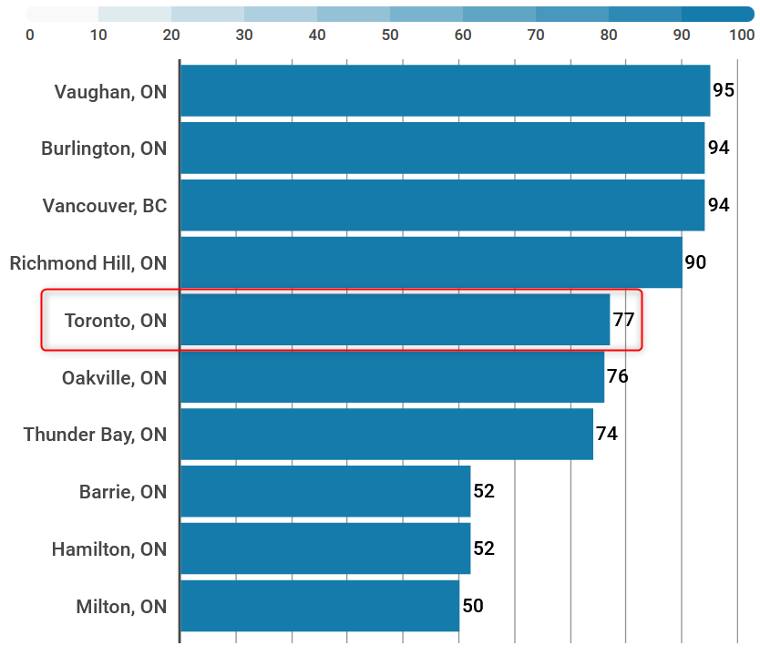

With this data it seems like a good decision fort he young pizza backer Giorgio to move to Toronto. However the question remains, which neighbourhood offers the best chances to start such a business. This analysis is done within this capstone project.

**Description of the data and how it will be used to solve the problem. (15 marks)**

The data that will be required will be a combination of CSV files that have been prepared for the purposes of the analysis from multiple sources which will provide the list of neighbourhoods in Toronto (via Wikipedia), the Geographical location of the neighbourhoods (via Geocoder package) and Venue data pertaining to Italian restaurants (via Foursquare). The Venue data will help find which neighbourhood is best suitable to open an Italian restaurant.

**Toronto Neighbourhoods (Wikipedia)**

Following Wikipedia site is used to get a list of postal codes in Canada where the first letter is M. Postal codes beginning with M are located within the city of Toronto in the province of Ontario.

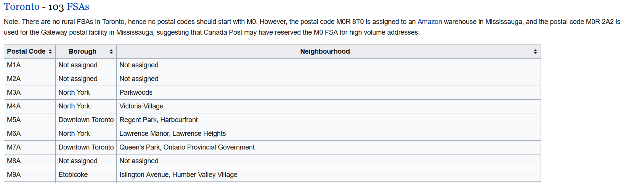

*Figure 1*: List of Neighbourhoods in Toronto with postal codes starting with „M“. Source: <https://en.wikipedia.org/w/index.php?title=List_of_postal_codes_of_Canada:_M&oldid=1011037969>

This table already includes the most important informations about the neighbourhoods (postal code, borough, name of neighbourhoods in Toronto). The data was scraped using BeautifulSoup as shown in the following figure:

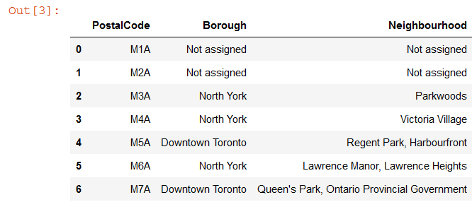

*Figure 2*: Data scraped from Wikipedia and included into Pandas DataFrame

**Geographical Location data using Geocoder Package**

The geographical location data was obtained from a csv-file found here: <https://cocl.us/Geospatial_data>

It includes Postal Code, Latitude and Longitude of the neighbourhoods. This allowed to add this information into the previous mentioned Pandas DataFrame:

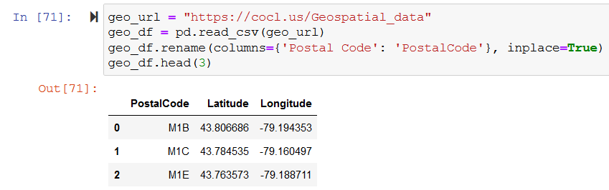

**Venue Data using Foursquare**

The data for different venues are obtained by the Foursquare API with personal credentials. Besides „Pizza Places“ this includes many other venue cagtegories like Flower Shop or Cafe.

<https://api.foursquare.com>